Teacher Pack: Call me by my name: Stories from Calais and Beyond

Call me by my name: stories from Calais and beyond is an exhibition hosted by the Migration Museum Project initially displayed in June 2016 at the Londonewcastle Project Space, Shoreditch. Over its three-week run, the Migration Museum Project welcomed students from 11 secondary schools in London and Kent for half-day workshops co-delivered with young refugees. These workshops received lots of positive feedback from both teachers and pupils who valued the chance to engage with the topic of migration – something which is so often headline news.

We just had the students back afterschool for a de-brief and they were still completely overwhelmed by the museum. Many of them talked about how their perceptions had shifted or how struck they were with the stories they had encountered, particularly Soli’s. I am sure that it has been the most valuable school trip that I have been on.

Sam Norwood, History Teacher, Robert Clack School, Dagenham

We need to put ourselves in the immigrants’ places and realise the struggles they go through. I feel like have been insighted [sic] with the truth of what is going on. I feel so grateful for living in Britain and I should not waste the chance I have to help people. Soli is my inspiration to dream for the stars.

Student from Robert Clack School, Dagenham

Call me by my name: stories from Calais and beyond is a multimedia exhibition which explores the complexity and human stories behind the current migration crisis, with a particular focus on the Calais camp. The Calais camp has become a potent symbol of Europe’s migration crisis. Public opinion on this ever-evolving shantytown and its inhabitants is polarised: to some a threatening swarm seeking entry to our already overstretched island-nation, to others a shameful symbol of our failed foreign policy. Amid such debate, it is easy to lose sight of the thousands of individuals who have found themselves in limbo in Calais, each with their own story and reasons for wanting to reach Britain. The exhibition showcases the work of artists both from here and from within the camp, to give a platform to those whose voices are so often lost amongst their media portrayal.

This pack is a resource for teachers to utilise both pre, post and during an exhibition visit with pre-planned lessons, focus questions, activity ideas and detailed notes for teacher led tour included. This pack has been designed by two qualified teachers and is suitable for students at either KS3 or KS4.

Please do let us know your comments if you have utilised all or some of this pack with your pupils and help to spread the word about the Migration Museum Project.

Emily Miller, Education Manager emily@migrationmuseum.org

Pre-Visit Lesson Plan

Resource | Activity
Introduction to the Migration Museum

- The Migration Museum Project plans to create the UK’s first dedicated Migration Museum and to tell the story of movement into and out of the UK in a fresh and engaging way.
- The museum will be an enquiry into who we are, where we came from and where we are going. Britons at home and abroad have a shared cultural history and an exciting future. We aim to represent the thrilling tales, the emotion and the history that have gone into shaping our national fabric; we aim to be the museum of all our stories.

For teacher’s interest:
About our project: http://migrationmuseum.org/about-our-project/

Video describing the Migration Museum Project: https://vimeo.com/102519336

Map of the world – This can be projected or a hard copy can be used.  Coloured Dots/ coloured board pens or post-its if doing it on a projected map. | Starter Activity  Students introduced to the concept of migration through thinking about their own migration histories. Students to stand in a line shoulder-to-shoulder and step forward when the statement related to their and their families’ experiences. Teacher to ask individuals to share some of their stories if they are comfortable doing so throughout the activity to promote discussion about the topic.  Step forward if:  - You have spent longer than one month consecutively in another country.  - You speak more than one language.  - You have lived outside of the UK.  - You have been on holiday outside of the UK.  - You were born outside of the UK  - You regularly eat food from different cultures besides your own.  - One of your grandparents migrated to the UK  - One of your grandparents emigrated from the UK for a substantial period of time (more than a year).  - One of your parents/guardians migrated to the UK  - One of your parents/guardians emigrated from the UK permanently or for a period of time.  - You have personally migrated to the UK.  Stick dots onto map:  - Yellow – where you were born. (1)  - Red – where your parents/guardians were born (2)  - Blue – where your grandparents were born (4)  Look at colour ratio for group.  Teacher to also undertake the task.  Important to remember that for many of our family members, this migration to or from the UK may have been out of choice rather than as a result of forced migration.
Terms and definition cards  See Appendix 1. | Introduction to Terms  This 8-minute introduction to International Migration gives an overview of the history of migration, keywords and push and pull factors in the context of the European Union.  http://migrationmuseum.org/introduction-to-international-migration/  - Reiterate that migration can often be a very sensitive subject – important to understand related terms and use them accurately within conversation.  - Put definitions down on a table/ground and give individuals words. They need to read the definitions in order to be able to match the word they have to the correct definition. This can be done as individuals or in pairs. For lower-ability groups, students can be given definitions which they need to match to the words.  These can then be read through together. Ask students to offer a mini case study/personal anecdote or something they may have seen in the news about each word.  e.g. Mohammed is an asylum seeker from Baghdad, Iraq. He is 15 and is still waiting alongside his parents for their application to be processed.
5 Images  Post-it notes.  Pens | Photographs and Post-it activity  Individually using a Post-it  Students to look at all five images - without titles or captions - which can be spread around the classroom. Using a Post-it note, students to choose one and write an answer to the following questions:  - Where has this photograph been taken?  - Who is in the photograph?  - Why are they experiencing the situation?  - What emotion is the sitter feeling?  - What is the aim of the photographer – what are we as the observer of this moment in time meant to feel?  Facilitate discussion once students have done this. Identify some students to share their ideas about the photographs – see if any others want to challenge their ideas/conclusions.  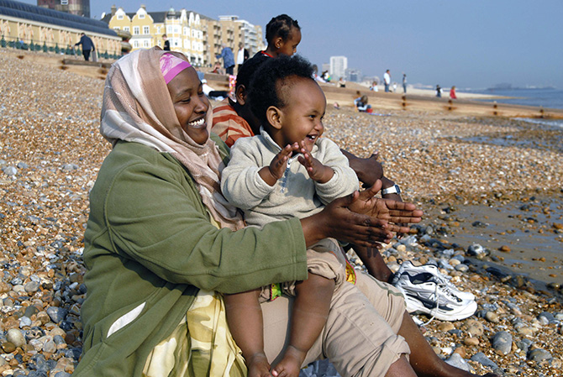  Oromo Family, Brighton, 2007 © Howard Davies  Yasser, Birmingham, 2010 © Dharmendra Patel  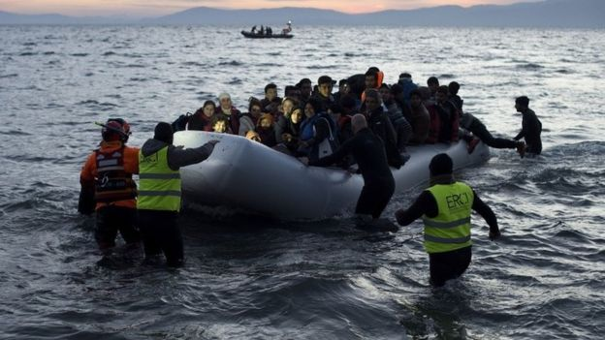  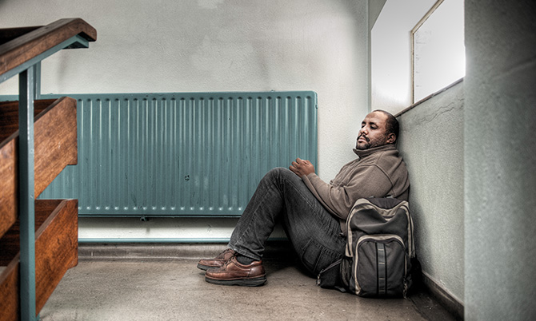  Volunteers and lifeguards help an inflatable boat after crossing the sea from Turkey.  BBC News © Getty Images http://www.bbc.co.uk/news/world-europe-35794563  Paul Evans, The Red Carpet  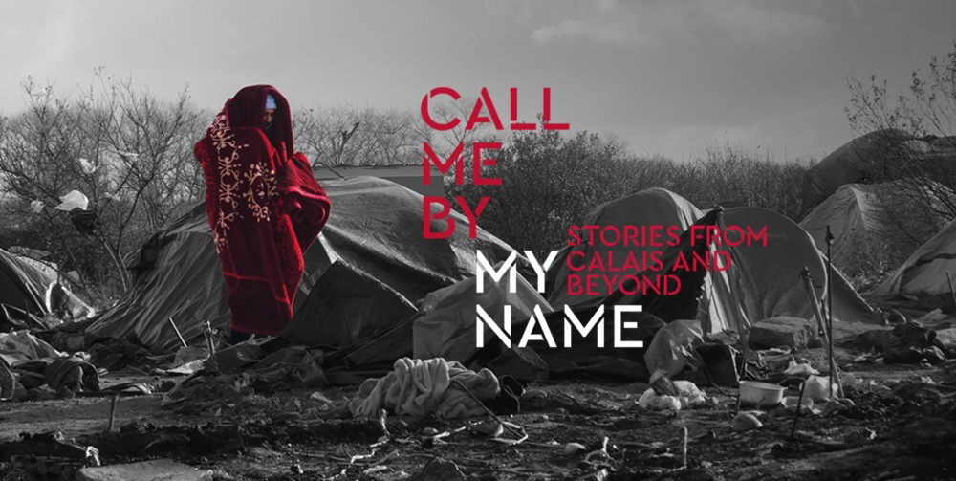  Abdul Alizedeh, carpet seller from Afghanistan, Jenny Matthews, 2012  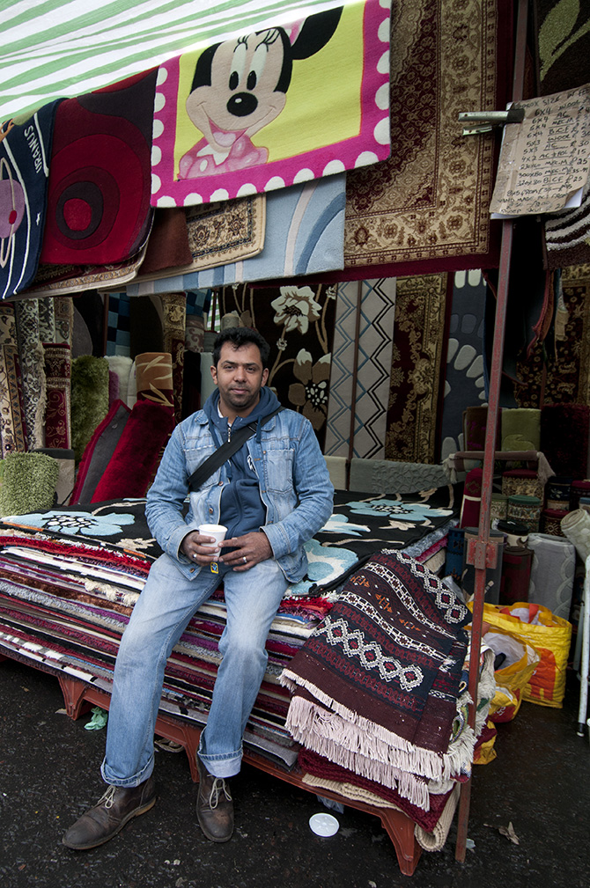
12:30 – 12:45  Titles and Captions to Photographs. | Matching up titles  Captions and titles laid out. Students to try and match captions to images. Can take one each and match them up.  Give students five minutes to go round and read them:  - Are there any that surprised you? Why?  - Are there any historical events/situations, which you haven’t previously come across?  - Do you have any questions about them?  Is there a common theme to the individuals in these images? – Forced migration/forced movement of individuals. These people have been forced to leave their home countries for a variety of reasons. Are there any images you feel that don’t fit into this criteria?  Forced migration – A migratory movement in which an element of coercion exists, including threats to life and livelihood, whether arising from natural or man-made causes with ideas:  Focus Question: Why individuals might experience forced migration?  E.g. war, persecution, poverty, lack of opportunity, job prospects, limited human rights, no access to health care, natural/environmental disasters, chemical/nuclear disasters, famine.
Titles and Captions to Photographs.  Terms and definition cards | Optional Activity  Using definitions from start of the session – match these words to the images, which you think best represent their meaning.  Get some students to explain their choices.
What is the Calais camp?
Why does it exist? How long has it been there? Who lives there? Where have the inhabitants come from?

What are you expecting to see in the exhibition?

Call me by my name: Stories from Calais and Beyond

- If you were putting on an exhibition – what would you try and show and why?
- What is the title hoping to convey?

Pre-visit resources
- Key word and definition cards
- Five migration images and captions

Keyword | Definition
Migration | People moving from one place to another
Immigration | The act of someone coming to live in a different country
Emigration | The act of someone leaving to go and live in a different country
Asylum Seeker | Someone who leaves their own country, often for political reasons or because of war, and who travels to another country hoping that the government will protect them and allow them to live there
Refugee | A person who has fled their country due to well-founded fear of persecution for political, religious or ethnic reasons, or because of war
Economic Migrant | Some who leaves their country and moves to another in search of better economic opportunities
Discrimination | Treating a person or particular group differently from how you treat others (in a negative way) because of their skin colour, sex, age, sexuality etc
Prejudice | An unfair and unreasonable opinion or feeling, especially when formed without enough thought or knowledge
Identity | Who a person is, or the qualities of a person or group that distinguishes them from others
Diversity | A range of people with different skin colours, languages, beliefs, customs etc
Diaspora | A scattered population with a common origin in a smaller geographic area. Diaspora can also refer to the movement of the population from its original homeland.
Integration | The process of joining and becoming part of a new society or culture
Smuggling | Move goods (someone or something) illegally in or out of a country.
Enslavement | To control someone by keeping the person in a bad or difficult situation where the person is not free.
Human Trafficking | The recruitment, transportation, transfer or receipt of persons by means of threat or use of force or other forms of cohesion.
IDP – Internally Displaced Person. | Person or groups of persons who have been forced or obliged to flee or to leave their homes or places of habitual residence who have not crossed an internationally recognised border.
Leave to Remain | Immigration status granted to a person who has been admitted to the UK without any time limit on his or her stay who is free to take up employment or study without restriction.
Deportation | The action of deporting a foreigner from a country.
Xenophobia | Attitudes prejudices and behaviour that reject or exclude persons based on the perception that they are outsiders or foreigners to that community.

Teacher-led Tour
Suggested teacher led tour of the exhibition Call me by my name: stories from Calais and beyond.

Entrance:  Larsen, Wanderers | Gather students around the sculpture and ask the students the following questions.  - What does this sculpture represent? Think of one word which best describes it.  - How is the artist trying to make us feel?  - Choose one of Larsen’s figures. You need to be able to justify why you have selected it.  - Once you have selected one, memorise its position in the ‘swarm’. Discuss: its size, its posture, its connecting figures or distinguishing features-if any.
Journeys | Gather the students together around the plaque that describes the story of these life-jackets.  Students should consider the owners of the lifejackets and the following questions:  - Why did they have to leave?  - Who are they?  Poem Reading – Ruth Padel – Time to Fly  https://soundcloud.com/new-networks-for-nature/ruth-padel-time-to-fly  5 minutes for students to look briefly around the room and take in first impressions.  Facilitated discussion.  -Why are people making the journey?  -What are the options?  -Who mostly makes the journey? What sex? What age?  -Where are they coming from?  -What are they leaving?  -What are the most common routes?  -How long does it take?  -What are the challenges along the way?  -Why do people ultimately want to come to Britain?  -What would you do if faced with the situation?  Option: Find an image which best matches/or that you associate with the figure that you picked out in the first room.
Identity | 5 minutes to look around.  Key questions to keep in mind:  -Who are the people in the camp?  -What are they trying to achieve?  -Why do they try to hide their names / faces / fingerprints?  More?  Interactive:  -Who was your Larsen figure? Discuss what person from room 2 might be the figure they chose. There might not be a direct representative of their character, but they might be able to associate their ‘wanderer’ to the images and stories in the museum.  Before student enter the Jungle room, get your students to contemplate the following questions:  What is the Calais Camp? Why is it there?  What words would you associate with the camps?
Jungle | Explore the gallery at your own pace.  Key questions:  -How long has the camp been there?  -What are the conditions in the camp?  -What has changed recently?  What words would you now associate with the camp?  Are they similar to the words you chose before you entered this room? Are they different?  Why have you chosen that specific word – is there a piece of art/quote that strongly gives you that impression?  Extension question:  -Who helps in the camp?  -Would you ever volunteer / what would you do?
Reflection | Complete the sheet.  Discussion once completed.  What struck you most about the exhibition? Is there anything that particularly surprised you?  Has the exhibition changed your understanding of migration? As a result – has your attitude changed at all?
Resources
- Information sheet re migration crisis. This may help teachers to prepare for discussions with students surrounding the Calais camp and migration.
- Reflection worksheet for students to fill out whilst in the exhibition.

Info sheet re: Migration crisis:

In some situations, people are forced to leave their homes
- Explain to class that people are sometimes forced to leave their home – there are around 60 million ‘displaced’ people in the world. There are lots of reasons for this including: war or fighting between different groups of people; being treated unfairly (discriminated against); and speaking out against the government which has put the person’s life in danger.
  - By foot:
  - By boat: a group of Syrian refugees arrive on the island of Lesbos after traveling in an inflatable raft from Turkey, near Skala Sykaminias, Greece. Read more about this in the teaching pack, including Why refugees are coming to Europe and Countries of Arrival on pages 15-20. See also http://www.unhcr.org/55c4d1fc2.html for more details.
  - By train:

There are currently 60 million displaced people. 5.1 million are Palestinian refugees.
- The total is around 60 million (there are over 15 million refugees under the UN Refugee Agency and around another 5.1 million Palestinian refugees registered by another special UN agency). It is important that pupils understand that when someone is forced to leave their home they may either stay in their own country or travel to a different country.

Crisis in Europe

- In 2015, over a million people arrived in Europe by land or sea; a quarter were children.
- Their journeys started from lots of different countries but especially Syria, Afghanistan and Iraq.
- 78 %of those who have claimed asylum in Europe in 2015 come from these three countries.

Why are people coming?

48% are from Syria: There has been a civil war in Syria since March 2011.
More than 250,000 people have been killed and over 11 million people displaced, 5.2 million of whom are children.

21% are from Afghanistan: Before the war in Syria forced millions of Syrians to become refugees, Afghanistan was considered by the UN Refugee Agency as having ”the world’s largest protracted refugee population”, with 2.6 million refugees living in 92 countries after three decades of conflict.

9% are from Iraq: United States-led forces removed Saddam Hussein, Iraq’s President, from power in 2003. He was later sentenced to death by an Iraqi court for crimes against humanity. Democratic elections were held in 2004, but violence and repression continues in the country.

The journey to Europe:
Discuss with the class some of the key routes people are taking to Europe that are shown on the map. In the case of people leaving Syria, Afghanistan and Iraq, remember, that many are now in countries such as Turkey, Jordan and Lebanon. For those who travelled on to Europe most people crossed the Aegean Sea from Turkey to reach Greece whilst some travelled by land to Greece or Bulgaria via Turkey. Once in Europe, some people have remained in that European country whilst others have travelled to other European countries.

What are the obstacles?
  - dangers within their home country;
  - lack of money to get out
  - methods of travel;
  - food and shelter;
  - language differences;
  - weather;
  - border controls; and
  - caring for sick and vulnerable family members,
including children.

Which children’s rights are under threat during the migration?

- Ask students to discuss what children’s rights are under threat and how these can be protected when children and young people flee to another country to seek asylum and refuge. Access to summary copies of the Convention on the Rights of the Child would help with this activity. See http://bit.ly/CRC-over11 for a summary of the Convention.
- Children’s rights affected include:
- non-discrimination (Article 2)
- best interests of the child (Article 3)
- life, survival & development (Article 6)
- birth, registration, name, nationality, care (Article 7)
- separation from parents (Article 9)
- respect for the views of the child (Article 12)
- the right to privacy (Article 16)
- protection from violence, abuse & neglect (Article 19)
- refugee status (Article 22)
- health and access to health services (Article 24)
- the right to an adequate standard of living (Article 27)
- the right to an education (Article 28) & the goals of education (Article 29)
- the right to leisure play and to take part in cultural & artistic activities (Article 31)
- the right to recovery from trauma and reintegration (Article 39)

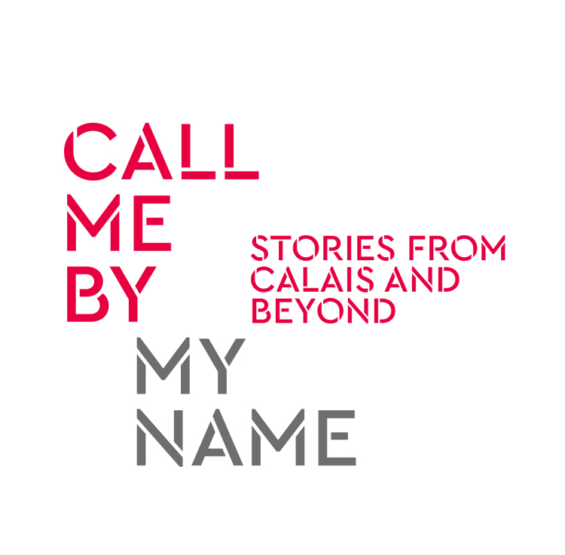
Reflection worksheet

This exhibition is full of different people’s opinions on and experiences of the refugee crisis and ‘the Jungle'. Take in some of these perspectives (on the opinion wall or in the Listening Hut) that stick out for you and summarise them below.
Notes here:

Take a look round room 2 (‘Identity’) and room 3 (‘The Jungle’) and find a piece of art created by a refugee or migrant artist in the camp that really struck you. This could be a painting / photo / sculpture…
Explain why you have chosen it:

At the start you were asked to choose one of Larsen’s ‘Wanderers’ with a reason for your choice. In room 1, 2 or 3 find a photo or opinion from the wall that most fits with the stick figure you chose.
Explain why it fits:

In room 3 ‘The Jungle’ you get a feel (from the tents / shelter / projection / films and images) about what life in ‘the Jungle’ is like. What do you think you would find personally challenging if you were stuck there for a few months.
Explain your answer:

Use this box to write down any questions that come up for you during this reflection time – anything that is unclear or you want more information on. We can then discuss these as a group:

Thank you for reflecting with us.

Post Visit Lesson

Timing / Resource | Activity
Photograph of The Wanderers, Nikolaj Bendix Skyum Larsen | 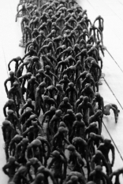  Recap the Call Me By My Name: Stories from Calais and Beyond exhibition.  Starter Questions  What can remember about this artwork?  What feelings does it provoke?  What was the key message?  What were your favourite aspects of the exhibition?
You may wish to provide images and excerpts from the comment wall from the exhibition to spark discussion. | Headlines Activity  Ask what sort of views students have seen on the news/TV/magazines about migration? (E.g. migrants are taking jobs, moving for benefits, etc.) Get these written onto the board and then ask students in groups to consider how what they found out from the Migration Museum Project challenges or confirms these ideas. You may wish to give students pictures of items in the gallery and excerpts from the comment wall to aid them.  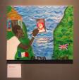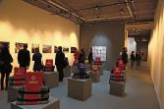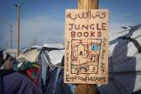  Class discussion on how the views compare to what you have seen in the Migration Museum and what you have found out about migration and the individuals.
Stick figure template | Stick figure template: My ‘Wanderer’  Building on what students have learnt from the museum, students can annotate and illustrate the blank stick figure of a migrant. They should base their ideas on the wanderer they chose at the beginning of their visit to the museum.  To include in their annotations…  - What is in their heart?  - What is on their mind?  - What is in their bag?  - What is behind them?  - What is in front of them?  Class discussion of their drawings may elucidate any common challenges and concerns facing those who travel to the UK.
List of statements | Statement Game  This can either be done as a line game (students arrange themselves along an imaginary line depending on their views about a statement) or through using traffic lights – (red – disagree, amber – not sure, green – agree).  Statements to be discussed:  - The media presents the migration crisis in an informative and balanced way.  - Migrants and refugees mainly want to come to England for the benefits.  - The migrants should stay and fight in the countries they come from – they should be more patriotic.  - Claiming asylum and achieving leave to remain is an easy process in the UK.  - People should not provide provisions like food and medicine to those in the camp – it only encourages more people to arrive.  - Refugee children travelling on their own should be accepted into the UK, the rest should not.  - Many people living in Calais are potential terrorists.  - Lorry drivers should try to help migrants and refugees more by giving them safe passage.  - There have never been movements of refugees like this before.  - We already have lots of social and economic problems here in the UK, accepting migrants and refugees will only make these problems worse.  - Many people in the UK have contradictory views about the refugee crisis and those caught up in it.  - People smugglers demand lots of money to transport refugees and migrants into Europe and across Europe.  - Many people want to ultimately return to their home countries.  - Migrating is always the easy choice.  - Some people experience a sense of community in the ‘Jungle’ despite the awful living conditions.  - The ‘Jungle’ should be made into a permanent city and all the migrants forced or encouraged to stay there forever.  - All of those currently residing in the ‘Jungle’ should be shared out into families across the counties in the UK.  - The ‘Jungle’ will eventually go away – when the people living there see that they can never get into the UK.  - There are other, bigger camps of refugees and migrants in Europe.  - Islam is the only religion practiced in the ‘Jungle’.  - France should agree to give Citizenship to all people living in the ‘Jungle’ – not Britain.  -A risk of the migration crisis is that it results in ‘brain drain’ of young talent from developing countries.  More Challenging  - The refugees should claim asylum in the first country in Europe they get to, not wait to try and get to the UK.  - The ISIS / Daesh attacks in Paris were a direct result of the migration crisis.  - This is not a humanitarian crisis. This is a political crisis. Politics needs to provide the answers.  - European countries should share out the burden of hosting refugees and migrants according to the country’s economic status.
Depending on the class, you may wish to choose one of the following activities.

- Conduct a debate on a topic listed above. If you are concerned about students not conducting this debate sensitively, then you could assign ‘roles’ with students preparing arguments from the point of view of child refugees, their families back in Syria, the French government, etc.
- Alternatively, students could compose and write a letter to refugee children through the charity Care4Calais: http://care4calais.org/childrens-letters/ These can then be shared with children living in the camp in Calais through social media and children there are given the opportunity to respond.

